Prayer 2024 Week 1

Look up: Psalm 19:1

Mike Colaw

Opening Illustration:

As a little boy, I remember sitting in a Sunday night church service. Church back then was so different than the Christian suburban production systems many of us know today. Nothing about those services was sensitive to those new to church. If you were new, the pastor might just have you stand up and share your name with the congregation. When the service started the music was a hymn call out. For those who don’t know, that’s when a music leader asks the congregation what song they would like to sing from the old hymnals in the wooden pews. Sunday night was often theology night. Deep sermons filled with buckets of Christian insider language. There would also be a substantial amount of time given to prayer and open 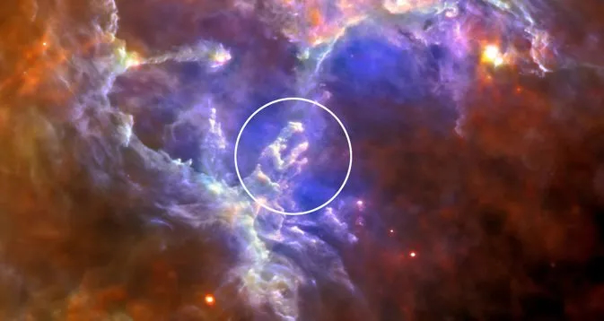testimonies. It was sometimes awkward hearing the things said from the front.

One time I remember us all bowing our heads and closing our eyes to pray.

For the first time, I thought, “Why do we have to close our eyes to pray?”

I don’t think it’s a bad thing to do this. Bowing can relate to humility. Closing your eyes can relate to turning away from distractions. These are good things.

However; The traditional posture of bowing down and closing off the world isn’t the only way to pray; you can also look up.

Lectio:

A thousand years before baby Jesus would come, an Israelite king named David walked outside one night to spend time with God. Instead of bowing his head, he looked up. The sky was full of beautiful things. King David stood there absolutely overwhelmed, and in prayerful worship wrote a poem. It opens like this:

Psalm 19:1

“The heavens declare the glory of God, and the sky above proclaims his handiwork.”[1]

I did a little original language work this week and came up with my own paraphrase.

The overwhelming beauty of the heavens echoes God’s voice. They are the all-encompassing poetic evidence that He is at work.

Joseph Addison, 18th-century poet.

The stars, “Forever singing, as they shine, The Hand that made us is Divine.” [2]

King David isn’t merely saying that the world is beautiful. The Psalms as a whole invite us to participate in this transcendent prayerful song of wonder.

When we look up and are captivated by the handiwork of God, we join in the same spectacular choir King David sang with. The stars don’t only sing for us but with us as we partake in enjoying the charitable love of God.

Let’s take a look at the night sky. (Have the three pictures ready to pull up.)

Thanks to modern technology, I can do more than talk about space. I can show you a picture.

Let me walk you through three images.[3]

1. The Night Sky: The first is a picture of the night sky. In the tiny pin of light in the center is the Eagle Nebula.
2. The Eagle Nebula: In the middle of the Eagle Nebula there are three pillars called the “Pillars of Creation.”
3. The Pillars of Creation: This little, pinprick of light in our sky is not only beautiful, it’s 3,341,172,664 Earths tall. If you were to take a road trip to see it in 10 million years of driving without stopping you would cover about 1/3 of the distance. This beautiful image is a divine factory. This is one place where stars are made. Billions of stars are constantly being birthed that will have billions of worlds around them.

Right before our eyes is the evidence of eternal omnipotence and it invites you to join in it’s song.

C.S. Lewis, “In commanding us to glorify Him, God is inviting us to enjoy Him.” [4]

St. Irenaeus, “The glory of God is a human being fully alive.” A person experiences life to the full when they are captivated by God. [5]

John Piper, “God is most glorified in us when we are most satisfied in him.” [6]

This last summer, I took a road trip out west with the family. It was wonderful. One night while we were staying in Wyoming, I took the kids way out in the middle of nowhere.

Kids: “Dad, where are we going?”

Dad: “Nowhere.”

Kids: “Well, what’s there?”

Dad: “Nothing.”

Kids: “What are we going to do?”

Dad: “We are going to see everything.”

Kids: “Kids: “But you said nothing is there.”

Dad: “I know, that’s how you see everything.”

Kids: “Ugh….”

A few minutes later.

Dad: “Alright kids we are here.”

Kids: “Where?”

Dad: “Nowhere… now get out of the car.”

I got them out of the car and asked them to simply look up. On that remote mountain pass my kids saw the sky for the first time away from civilization’s light pollution. In the city you can see a few dozen or maybe a few hundred stars. In the real country, they are nearly uncountable. “Dad, that’s amazing!” They broke out their cell phones and started taking pictures. After a few moments they realized, the pictures couldn’t compare to just being there. Eventually we all found ourselves with no phones out and few words spoken, just lost in the big western country sky. At one point I looked at them enjoying it all. I enjoyed them taking joy in the moment. That’s it.

That’s what prayerful “looking up” is. It is us taking joy in God as God takes joy in us taking joy in Him.

I believe an often-overlooked part of prayer isn’t us asking God for things or our will actualized. I think one of the core purposes of prayer is being lost in the beauty of God. Look up.

Psalm 19:1 “The heavens declare the glory of God, and the sky above proclaims his handiwork.”

Oh, but there is even better news. God is not only big, but he is also personal. You’ll have to come back next week for this.

Next Steps: Join us for the 21 Days of Prayer.

1. 1 Psalm 19:1 (English Standard Version).
2. Addison, Joseph, The Spacious Firmament on High; https://poets.org/poem/spacious-firmament-high
3. Webb, James telescope images. <https://webbtelescope.org/news/first-images/gallery>
4. Lewis, C.S. Reflections on the Psalms. New York: Harcourt Brace and World, 1958, p. 97.
5. Irenaeus. Against Heresies, Book IV, Ch. XX, no. 6–7. Circa 185 AD
6. Piper, John. Desiring God: Meditations of a Christian Hedonist. Multnomah Books, 1986.